**User Guide**

**Log In**

The first screen all users will see is the login screen.

Customers can login to their accounts using this screen.

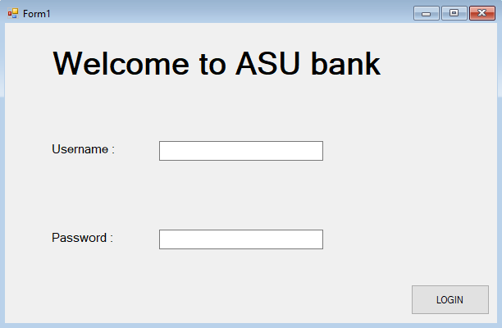

**Services**

After Login, all customers go to the service page.

In this page customers can go to cheque services, view account, transfer funds, bills, utility form or exit the program.

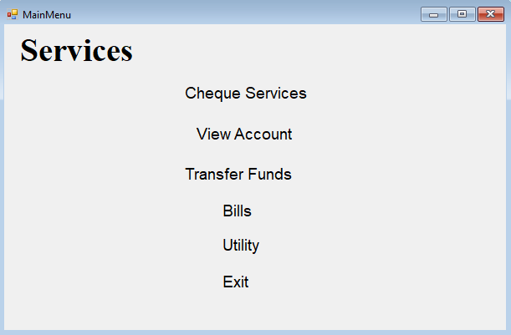

**Cheque Services**

In the Cheque Service customer can control everything about his cheques

Starting with the Cheque status, User can view the status of all his issued and waiting clearance cheques.

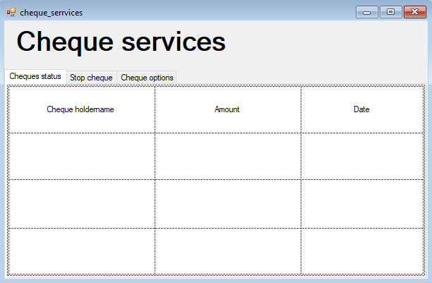

In this tab, user will see his issued cheque and can stop them.

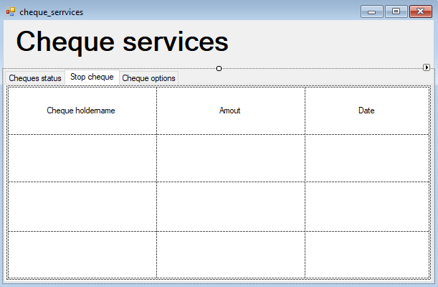

In this tab, user can request a new cheque book to go to the bank and collect it afterwards.

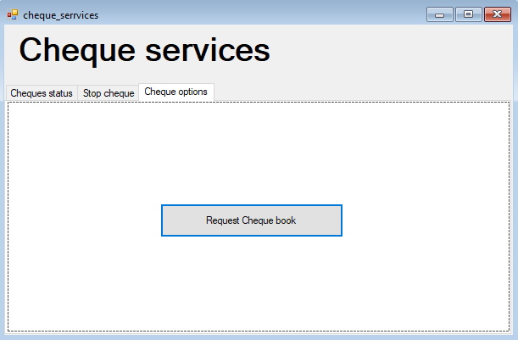

**Transfer Funds**

In the transfer funds form user can transfer funds from his account to any other account with the currency he wants.

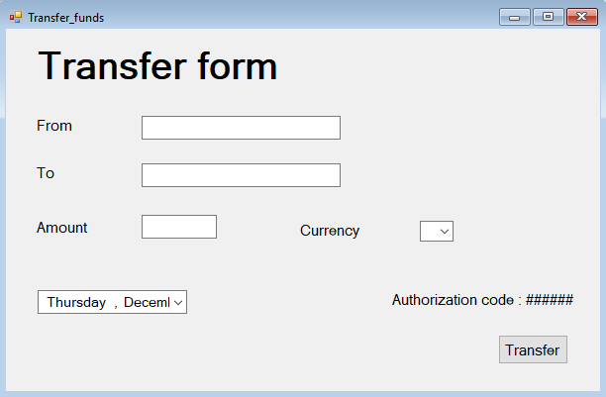

**Bills**

In the Bill Form customer can control everything about his Bills.

The first tab is the bill history, which shows the bills that have been paid by this account.

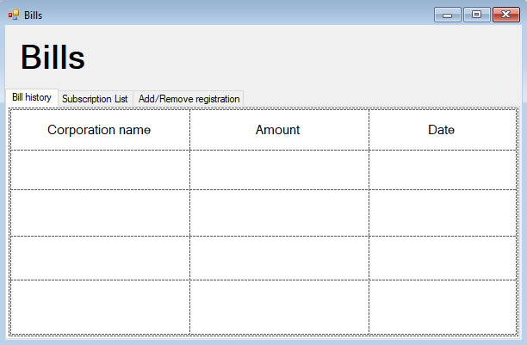

The second tab, it the Subscription list, which shows the bills that are currently associated with the account for payment.

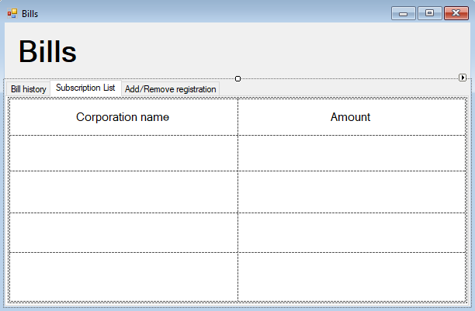

The last tab, gives the user the ability to add or remove registration of bills(subscriptions).

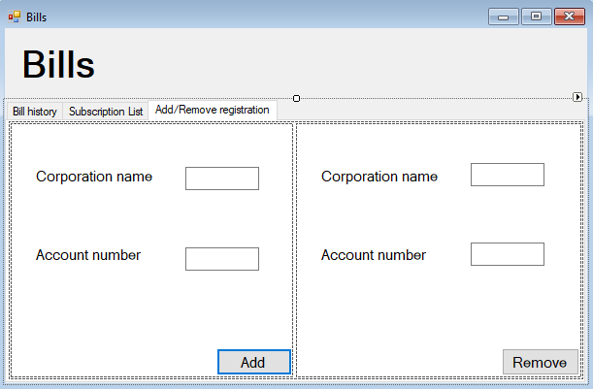

**View account**

In this form user can see his current account and his saving account information: balance, transaction history and his associated cards to each account.

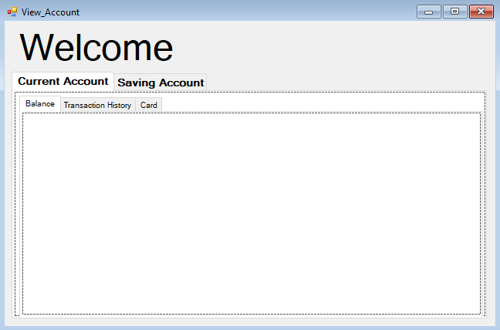

**Utility**

In the utility form, user can change a lot of setting of his account.

He can change his password, personal information, view logs to the account and cancel ATM the use of ATM.

